

CP2406 Programming 3 Assignment 1

Jianhao Chen

[Company Name]

# **User Stories**

User Story 1:

As for the user, I want to keep the the running interface should be as tidy as possible, so as not to interfere with the simulation process by too many buttons or windows. For the testing. devide the program into two modes: city editing and simulation, Put simulation-related windows and buttons in simulation mode. Put others in city editing mode.

User story2

As for the user, I want to develop check and reload the past simulator, and keep my all changes detail can not be disappeared, for the testing , there should be the ‘open’ ’save’ button in city mode .

User story 3:

As for the user, I want to check and fix the detail of the simulator process .so I need to can stop the dynamic simulator process at any time during the simulator process running. For testing, there should be a ‘stop’ button in simulator mode.

User story 4:

As for the user, I want to develop the simulator customization so I can edit the car, road and length for that, and want to edit the shapes of the road and the location of traffic lights, to create an exclusive map to simulate some specific traffic conditions.

User story 5:

As for the user, I want to control each step in whole simulator process, so that I can observe each changes of the simulator elements. For the testing, simulator mode do not need a continuing-dynamic process, need a ‘update’ button to start a new update cycle. Vehicles don’t move continuously over a lane – each update cycle causes the car to move some number of lane segments (based on its current speed)

User story 6

As for the user, I want to cars disappeared after reaching the end to maintain a constant number of cars on the road.

User story7

As for the user, I want the cars on the road to drive at a constant speed.. so that I can control how many vehicles should place on the road by updating vehicle rate.

## Developer User Stories

Developer User story 1

As for a developer, need to make a program to save users’ city data, and make sure that the data can be change and running after reload. Priority is High and Estimate time is 3 days. For the testing, save the all data as a file at main method and load the data to view the map again.

Developer User Story 2

Developers can also stop the cars traffic to avoid collision with in front of car, there will be no error at all. Priority is Low and Estimate time is 2 days. As for the testing: get the gab distance from the front of vehicles and call some methods from vehicles.

Developer User story 3

Developer make the program to save all of the data that cant occur data missing to customers. Priority is High and Estimate time is 3 days. For the testing, save the all data as a file at main method and load the data to view the map again.

Developer User story 4

As for the developer, I want to load some of all data that user created so that all data can load and run again after program started. Priority is Medium and Estimate time is 1 day. For the testing, at main method, read the data file from the specific path and load the data

# **UML Diagram**

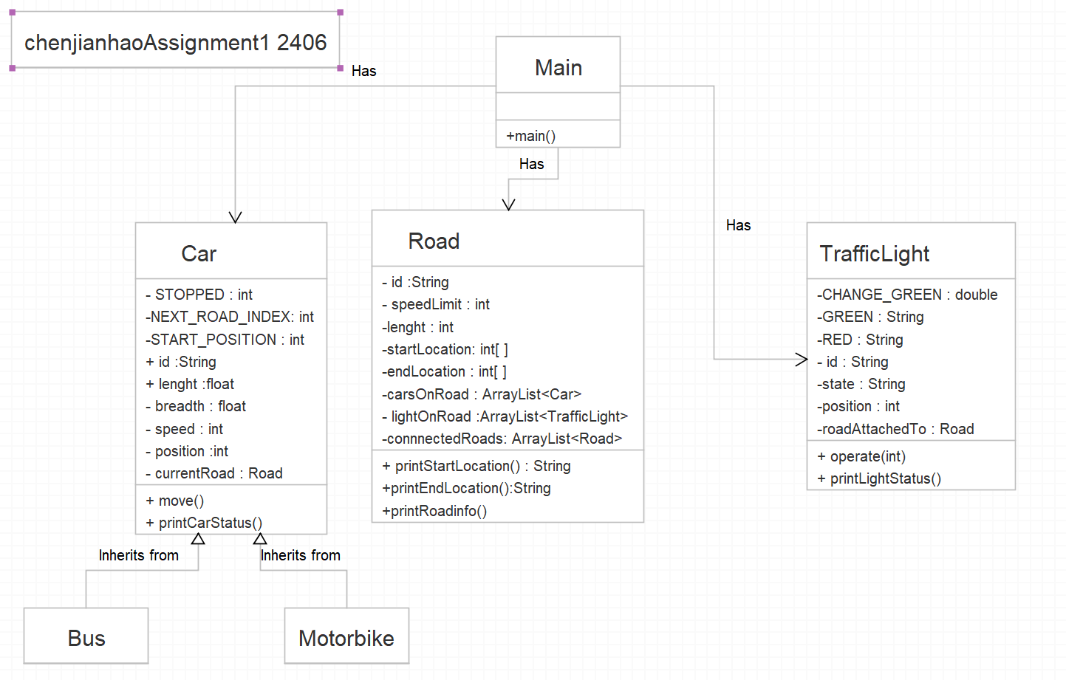

# **GitHub**